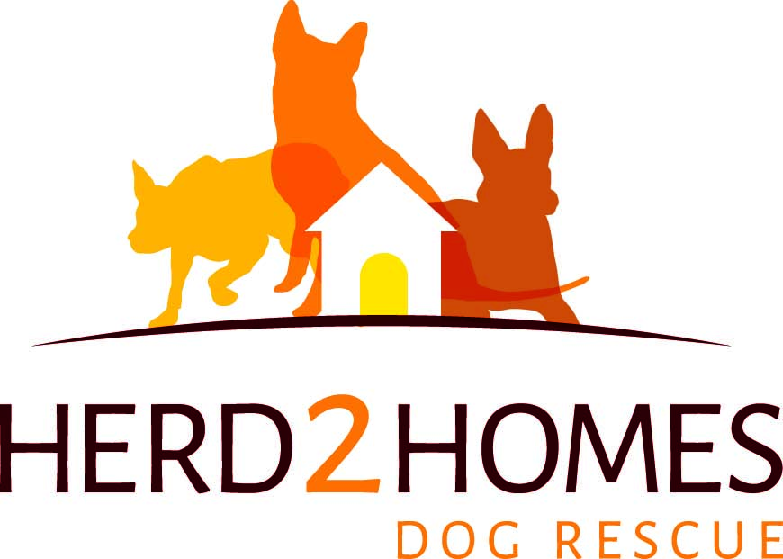
herd2homes@gmail.com

Surrender a dog/s to herd2homes Dog Rescue Inc.

Owner Details:
Full Name:_________________________________________
Contact Phone Number: ___________________________ Alternative Phone Number:______________________
Email:___________________________________
Address:______________________________________________________________________________________
______________________________________________________________________________________________

Dog Details: (The more information you are able to provide, the better equipped we will be to assess if we have a suitable foster carer and home available).
Name of Dog/s to be surrendered: ________________________________________________________________
Breed/s and colourings/markings:________________________________________________________________
Age/s:________________________________________________________________________________________
Microchipped?(Yes/No)_________ Microchip Number:_______________________________________________
Is the microchip registered to your name?(Yes/No):__________________
If no, please provide name, email and contact number of person the dog is registered to:__________________
______________________________________________________________________________________________
When was the dog’s last vaccination?_____________________________________________________________
Is the dog desexed?(Yes/No)________________
Who was the dog’s regular vet?(Name & Number):___________________________________________________
Current health status, and any health concerns?:____________________________________________________
______________________________________________________________________________________________

Reasons for wanting to rehome this dog?__________________________________________________________
_____________________________________________________________________________________________
_____________________________________________________________________________________________
_____________________________________________________________________________________________
_____________________________________________________________________________________________
Photograph of dog/s wishing to be surrendered attached?(Yes/No):____________ (please be advised by a attaching a photo, this will help us make a more accurate assessment of our ability to take your dog/s into care and their chances of being adopted)

Declaration:
I understand that by completing this form, herd2homes Dog Rescue Inc. are under no obligation to take this particular dog from me, and will assess the dog’s details and suitability for foster care and rehoming through herd2homes Dog Rescue Inc., and provide me with a timely response.
I understand and accept that by surrendering the above mentioned dog/s to herd2homes Dog Rescue Inc., I am relinquishing all rights, responsibilities and any further claim to this dog/s now and in the future.
I have completed the above form honestly and truthfully in regards to the dog’s details, issues and current state of health.
By signing below, I confirm I am the registered and microchipped owner or sole owner of this dog, and have the right to surrender this dog to herd2homes Dog Rescue Inc.

Signed(applicant):__________________________________________
Print Name:_____________________________________________________ Date:____________________
Signed (Witness):________________________________________________
Print Name (Witness):_____________________________________________ Date:___________________

Signed(herd2homes Dog Rescue Inc. representative):__________________________________________
Print Name:_____________________________________________________ Date:___________________

